

**ASSIGNMENT #1**

**SUBMITTED BY:** Kulsoom Khurshid

**REGISTRATION #:** SP20-BCS-044

**COURSE:** Web Technologies

**SUBMITTED TO:** DR Muhammad Imran

**QUESTION #1**

Set the box-sizing property to each of the values; content-box and border-box, describe and justify the impact of these different attribute values on the layout design.

**ANS:**

box-sizing : content-box

For content-box, the width and height of the element does not include margin, border and padding. It only includes the content.

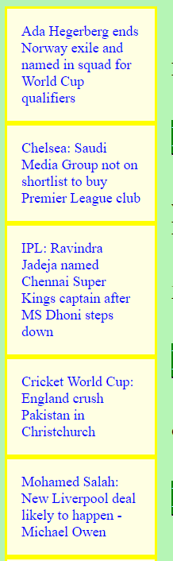I have used box-sizing for aside section.

The total width that I assigned was 100px, but this 100px is only for content not for margin, border or padding. Content-box has more space than border box.

box-sizing : border-box

For border-box, the width and height of the element include margin, border and padding along with the content.

if the property of box-sizing is border box then the width 100px include left margin, right margin, left border, right border, left padding, right padding and content.